“Your Story, My Story, Our Story”
Exploring Personal and Global Cultures through Literacy

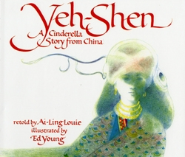
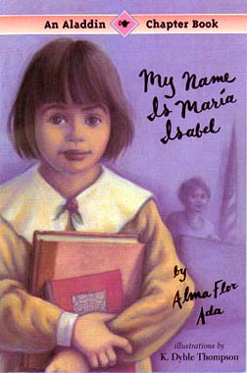
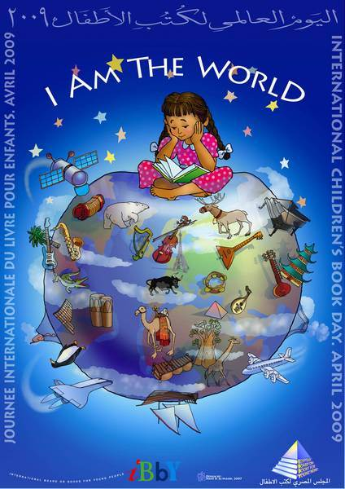

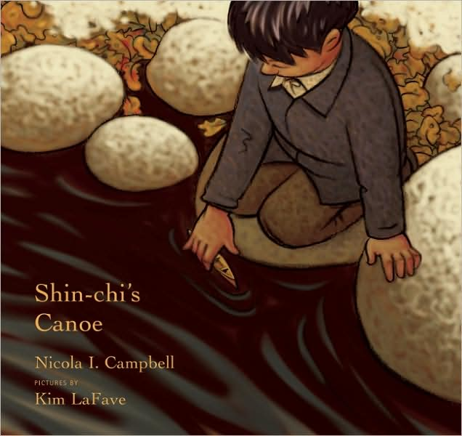
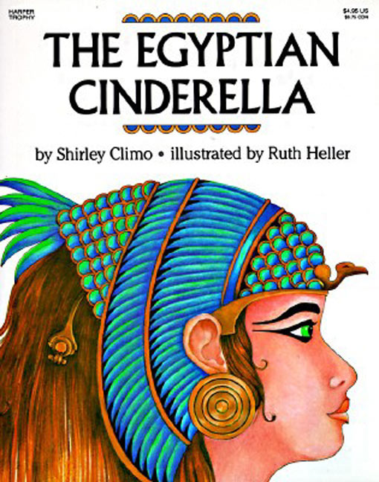

A Flat Classroom Proposal
By: Roselyn Vazquez
University of Saint Joseph
EDUC: 555 Science and Social Studies Inquiry
December 5, 2012

Project Title: “Your Story, My Story, Our Story”
Exploring Personal and Global Cultures through Literacy

Generation: Grade 1 (Please not that this project could be implemented in all grades throughout elementary, middle and high school).

Project Idea: When most of us think about culture, we often focus on the surface elements of culture such as food, dress, art, music and many celebrations of a group of people. However, culture is so much more than that. The purpose of this project is to look beyond the basics of culture and engage students in a deep exploration of culture though literature. I will incorporate literature from the United States and literature from different countries. My goal is to widen children’s perspectives of the world, themselves and others by making connections among the many different cultures that will be explored throughout this project.
“The best books break down borders” (Jewett, 2011). “They change our view of ourselves: they extend that phase “like me” to include what is foreign and strange.”

The project will be composed of two different phases.
In Phase I: Students will identify and understand what makes their own cultures.
In Phase II: Students will explore global culture and identify points of view beyond their own cultures.

Curriculum Integration and Alignment: The curriculum will be interdisciplinary in the contents of Social Studies, Language Arts and Technology.

Communication: Personal Writing, Collaborative Group Discussions, E-Mail, Skype, KidBlog, Weebly, Glogster

Time: 12 weeks
Phase I: (Weeks 1 – 4) Exploring our own cultures
- Students will explore their own cultures (this will include neighborhood and family interactions).
- Students will use photographs, stories, books, arts, traditions and customs to explore their own cultures.

- Students will continue to explore their own cultures and make connections with one another in the classroom.
- They will collaborate and share with one another their feelings about their traditions, holidays, their similarities and differences between their cultures.
- Students will learn about one another and where they come from. (Families are encouraged to participate. If students have family members that live in different countries we will make arrangements to set up a Skype Session with such family members).
- Students will use Glogster to build an electronic collage of photographs that they identify as culture.
- Students will complete week two and their examination of their cultures by building their own World Map.
- Students will print out or draw a large copy of a world map. The photographs of each student from the class will be pinned to the map based on the part of the country they are from.

Phase II: (Weeks 5 – 12)
- Students will explore familiar stories as told through different cultures. (i.e., classic folktales, such as Cinderella, The Persian Cinderella, Yeh-Shen (A Cinderella story from China), The Korean Cinderella, The Egyptian Cinderella, etc).
- Students will work collaboratively as they explore these stories and examine the differences and similarities as they relate to culture and social issues. They will make connections to stories they are familiar with.
- They will make person-to-person connections as they explore the deeper issues throughout the stories. How do the stories change when told from different cultural backgrounds?
- Students will locate the different countries references in the folktales in their world map.
- Students will share and discuss if they know anyone from the different countries referenced.
- Students will log into Kid Blog and blog about the different stories, their feelings, emotions, opinions, etc.
- Students would create a collage of the different country’s folktales.
- Students will begin selecting their favorite books (we will be making a Tab in our class Weebly under resources and compose a list of books they will suggest for students all over the country to read.
- Students will continue reading cultural literature and U.S. literature in the topics of holidays, traditions, education, families, foods, government, etc., as it relates to different countries. (Some of the Countries that will be included in this project will include Mexico, Egypt, Korea, China, Africa, Afghanistan, Cuba, Puerto Rico, Polland, Turkey, Maasai, etc.)
- Students will explore fiction and non-fiction literature throughout this project.
- Students will create cultural x-rays (an activity that in which they draw a person with a big heart as the center of the body. Students write how the person seems in the outside around the outline of the drawing and different words to describe the person in the inside (in the heart). (This Idea was obtained http://www.childrensliteratureassembly.org/docs/pamela-jewett-article.pdf)
- Students will blog about the different cultural literature they read and continue to make day-to-day, person-to-person, culture-to-culture connections.
- Student will use KidBlog, Glogster and Weebly to engage in discussions, writing and creating visual representation of their project.
- Authors from different countries will be invited to a Skype Session.
- At the end of the project students will reflect and share what they have learned and how they view culture now as opposed to the beginning. Students will give recommendations on how to implement a project like this in other countries. Students will have an end of project celebration that will include gallery walks, sharing their blogs with families and friends, a party that will incorporate food and music from various cultures. Parents, families and friends will be invited to share stories or retell stories they are familiar with.

Information/Materials: U.S. and Cultural Children’s Literature (many different children’s books from the U.S. and international will be used throughout this project). Different sources will be used to select the literature that will be used throughout this project. Below are a few:
http://en.childrenslibrary.org/
http://www.childrensliteratureassembly.org/docs/pamela-jewett-article.pdf
http://www.ipl.org/div/pf/entry/48493
http://www.multiculturalchildrenslit.com/
http://www.childrensliteratureassembly.org/
http://www.education.wisc.edu/ccbc/books/detailListBooks.asp?idBookLists=42
Other supplies will include: paper, pens, markers, poster paper, computer, iPads (with internet access).
Standards Alignment
Social Studies:
Content Suggestion: Family is a context to expand knowledge of geography, history, human interdependence, etc., include comparisons to families in other regions, states or countries.
Standard 1: Content Knowledge: Knowledge of concepts, themes and information from history and social studies is necessary to promote understanding of our nation and our world.
1.3 – Significant events and themes in world history/international studies.
5. Analyze how one’s own cultural heritage (e.g. holiday celebrations, dress and customs) has changed over time.
Standard 2: History/Social Studies Literacy: Competence in literacy, and research skills is necessary to analyze, evaluate and present history and social studies information.
2.3 – Create various forms of written work (e.g. journal, essay, blog, Web Page, brochure) to demonstrate an understanding of history and social studies issues.
2.4 – Demonstrate an ability to participate in social studies discourse through informed discussion, debate and effective oral presentation.
8. Participate in collaborative conversations with diverse partners about social studies topics and texts with peers and adults in smaller and larger groups.
Language Arts
CC.1.R.L.2 - Retell stories, including key details, and demonstrate understanding of their central message or lesson.
CC.1.R.I.3 - Describe the connection between two individuals, events, ideas, or pieces of information in a text.
CC.1.R.I.9 - Identify basic similarities in and differences between two texts on the same topic (e.g., in illustrations, descriptions, or procedures).
CC.1.SL.1 - Participate in collaborative conversations with diverse partners about grade 1 topics and texts with peers and adults in small and larger groups.
CC.1.SL.1.b - Build on others’ talk in conversations by responding to the comments of others through multiple exchanges.
Technology
This project aligns with all six National Educational Technology Standards.

Learning Legacy: Students will alter their views of the world by exploring their cultures and the cultures of others. They will experience traditions and feelings though cultural exposure. A project such as this one, especially in the first grade, will allow students a potential to understand culture, traditions, rules, etc. from many different points of view. Students will appreciate their cultural similarities and differences and build from those experiences rather than look away from the unknown.

Guiding Questions: “What is culture?” “How do you identify with culture?” “How do you view culture?”

Project Aims: This project aims at exposing young children to explore personal and global cultures through literacy in an attempt to expose them to different perspectives and views from around the world.

Focus Questions: How do we explore culture through literature? How do stories shape our cultures and views of the world? How are different cultures similar? How are different cultures different? How different are we really? How do we view the world from what we know now? How will we view the world differently?

Prerequisites and Skill Level: Students will have some skills on basic computer navigation and basic internet skills as well as blogging and safety rules for internet/blogging. Students will have their own interpretation and definition of culture(s). Students will be familiar with classic children’s literature.

Required Outcomes: Students will be exposed to different children’s literature from the U.S. and from other countries. Students will begin to grow as Global Citizens. Each student will have his/her own blog though Kid Blog. Each student would have contributed and/or referred a book to our classroom resource list.

Optional Outcomes: Students will continue to read literature from all over the world.

Team Structure: Students will work in their own classrooms. They will also work at home (not homework) in obtaining photographs or artifacts or books that will help them explore their cultures. Students will work in the classroom collaboratively and independently. They will contribute to the class Weebly Site and to their Kid Blogs.

Required Inputs: Students will bring artifacts (i.e. photographs, books) from home. They will explore U.S. and International Literature. They will collaborate in discussions about literature, culture, traditions, etc. They will blog about their experience. They will share their blogs, books and collages in a final end of project celebration.

Optional Inputs: Some students will want to engage in further exploration. Students will bring additional literature home or to the class and share. Students may help guide other students and work with them in making personal connections.

Assessment: Each individual student blog will be used for assessments purposes. Assessment will also be conducted informally during class/group/individual discussions, book selections, class participation, student engagements, etc.

Evaluation: Student’s Glogster, Weebly resource page, surveys, student’s blog, class projects, final projects, collaboration efforts, discussions, etc.

Benefits for Students: This project will expose students to personal and global culture exploration. It will alter students’ view of the world as they make person-to-person, world-to-world, culture-to-culture connections. Student will begin to grow as global citizens as they explore the world through literature. They will increase their view of what culture is and how culture can be defined in many different aspects.

References:

Proposal framework courtesy of Lindsay, J. & Davis, V.A. (2013). Flattening classrooms, engaging minds: Move to global collaboration one step at a time. Boston, MA: Pearson Education, Inc.

Jewitt, P., (2011). “Some People Do Things Different From Us.” Exploring Personal and Global Cultures in a First Grade Classroom. The Journal of Children’s Literature, 37(1), pp. 20-29.

